author : JACOT, Valentine

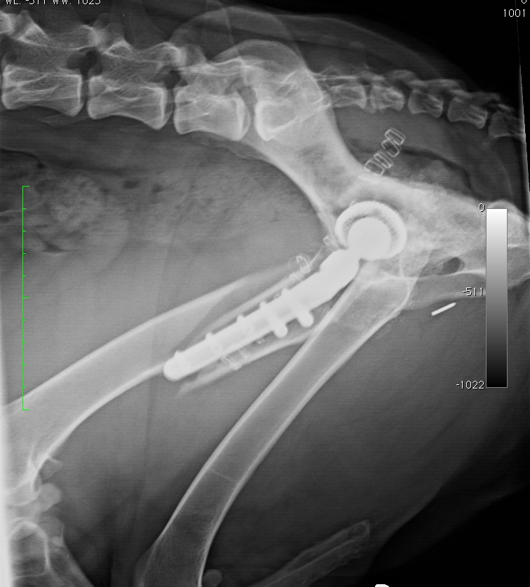
Vetsuisse Faculty University of Zurich
small animals clinic

